Laboratory WORK REPORT №1

«Simple semiconductor device circuits design and simulation»

(Includes Practice 1 Report)

**Principles of Circuits**

Student: CAO Xinyang 20321308

Program of Automation/ of Computer Science and Technology

group №

Name Surname

# Work purpose: to study parameters of semiconductor elements and basis of the semiconductor device design

Goals:

1) Design rectifier model on the basis of diode «diode name»

2) Simulate rectifier scheme and analyze dependencies of DC voltage ripple from load and filter capacitor values variation

3) Simulate overvoltage and overcurrent states (optional)

# Starting data

### Parameters of the voltage source:

* One-phase sine voltage source
* Rectifier scheme: Half-Wave Rectifier (HWR) /Central tap rectifier (CTR) /Full -Bridge rectifier (FBR)
* Source voltage amplitude

$V_{s}$ = 50 (V)

* Source voltage frequency

f= 100 (Hz)

### Diode: (copy the 1stand the second line of .lib file of your variant)

### Required parameters of DC output:

* Load resistance:

RL = RLOAD_HWR/CTR/FBR = 180 (V)

* Desired DC voltage ripple factor:

Kp =.035

# **Simulation report**

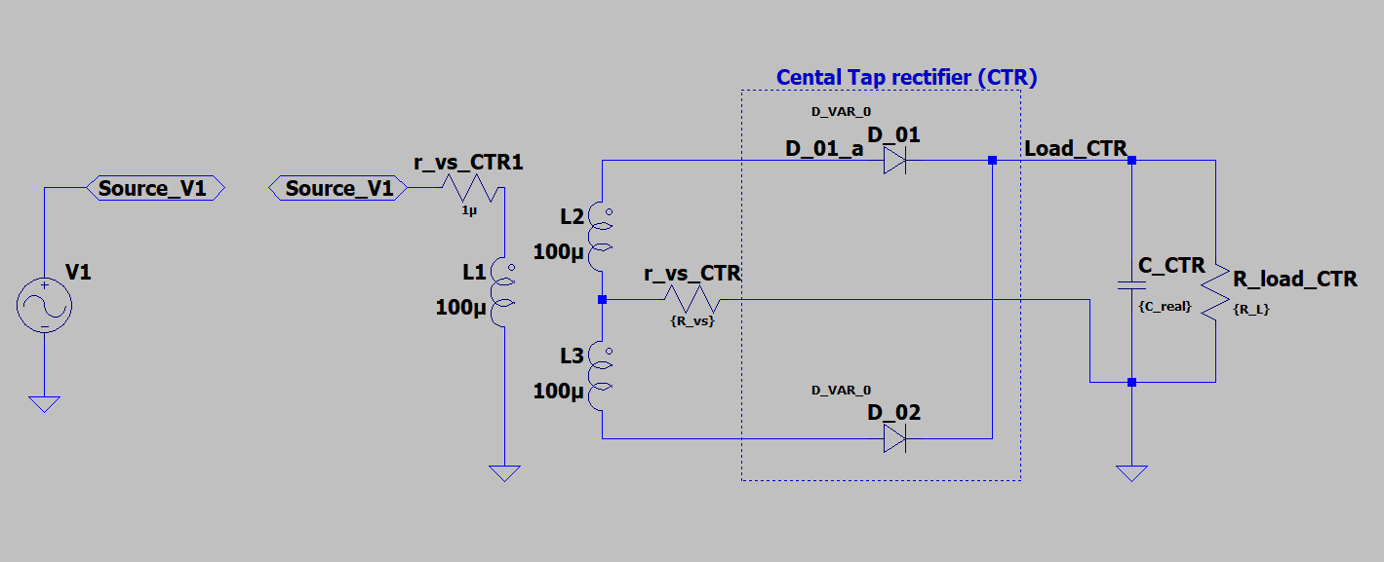

Fig. 3.1 – Rectifier scheme model

### Filter parameters:

* $C_{real}^{ }$ = 300 (uF)

### Load parameters:

* RL = RLOAD_HWR = 180 (Ω)
* $V_{{R_{L}}_{AVG}}$ 46.84 (V)
* $V_{{R_{L}}_{RMS}}$ 46.91 (V)
* $K_{p}=K_{p}=\frac{ΔV_{R_{L}}}{2V_{{R_{L}}_{AVG}}}=$ 0.035
* $I_{{VD}_{ON}}=$ 28.69 (A)
* $I_{{VD}_{max}}=$ 1.81 (A)
* ${ΔV}_{R_{L}}$ = 3.28 (V)

## Simulation results

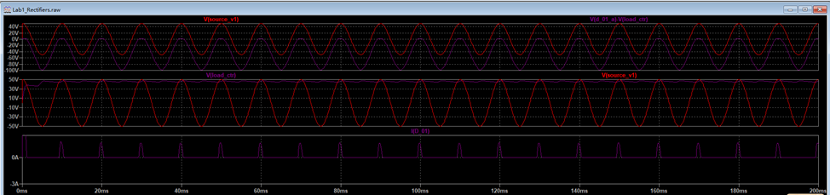

Fig 3.2 – Simulation results

### Ripple factor:

#### Required:

* + Kp = 0.035

#### Simulated with 0.8

* + KP_EXP= 0.034

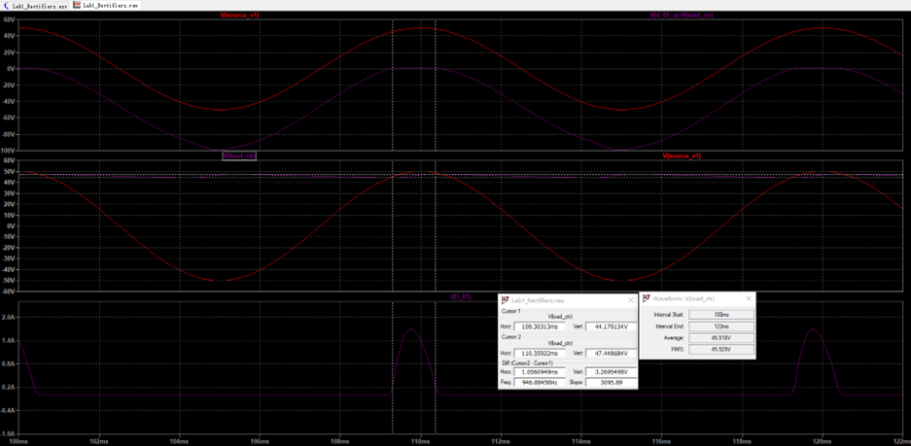

b) Full-bridge rectifier

Fig 3.3 –Voltage ripple analysis

To define Average and RMS values use CTRL+left click mouse button on the signal name. Use 2-3 Voltage periods in the end of simulation interval

Right-click with mouse on the signal name gives access to the signal cursor

### Voltage ripple from simulation results

$V_{{R_{L}}_{AVG}exp}=$ 45.918 (V)

$V_{{R_{L}}_{RMS}exp}=$ 45.929 (V)

$V_{{R_{L}}_{max}}=47.45$ (V)

$V_{{R_{L}}_{min}}=44.18$ (V)

$ΔV_{R_{L}exp}=V_{{R_{L}}_{max}}-V_{{R_{L}}_{min}}=$ 3.27 (V)

### Ripple factor

$K_{Pexp}=\sqrt{{\left(\frac{V_{R_{L}_RMS}}{V_{{R_{L}}_{AVG}}}\right)}^{2}-1}=$ 0.021

$K_{pRMS}≈\sqrt{{\left(\frac{V_{{R_{L}}_{RMS}}}{V_{{R_{L}}_{AVG}}}\right)}^{2}-1}≈\frac{\frac{V_{{R_{L}}_{max}}-V_{{R_{L}}_{min}}}{2\sqrt{3}}}{V_{{R_{L}}_{AVG}exp}}=$ 0.021

Diode opening state angle:

$τ_{1}=$ 0.00107 (s)

$θ_{exp}=τ_{1}∙f∙2π=\frac{τ_{1}}{T}∙2π$ =0.672 (rad)

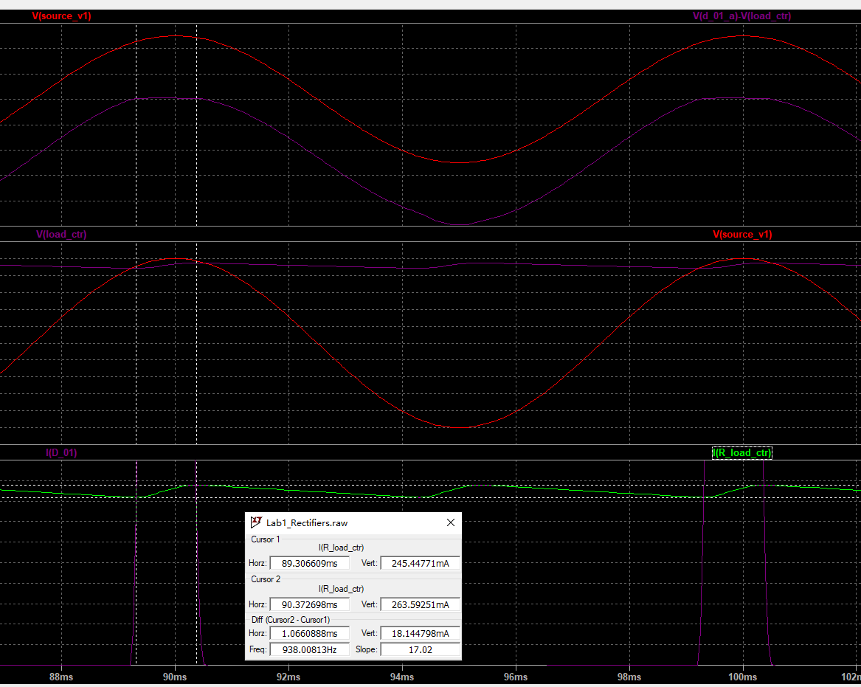

Fig 3.4 – $θ_{exp}$ angle definition from simulation results(It is recommended to consider diode open state at current level 0.05-0.1A or determine theta on the capacitor charging interval)

### Average rectifier scheme diode current (To define Average and RMS values use CTRL+left click mouse button on the signal name. Use 2-3 Voltage periods in the end of simulation interval)

$I_{VDexp}=$ 0.133 (A)

### Starting (Non-repetitive) maximum peak surge diode current in rectifier scheme

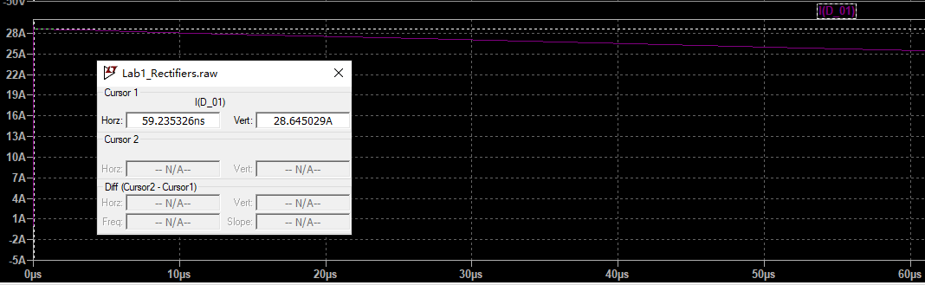

Fig 3.5 –Starting current

$I_{{VD}_{ON}exp}=$ 28.65 (A)

Practice REPORT №1

«Simple semiconductor device circuits design and simulation»

# Rectifier evaluation

## Diode simulation parameters evaluation

### Datasheet parameters:

|  |
| --- |
|  |
| а) |
|  |

Fig.4.1 – Diode parameters for 25⁰C

* Maximum average rectified current

$I_{fwd_AVG}=1.0$ (A)

* Maximum peak reverse voltage

$V_{reverse_imp}=100$ $(V)$

* Maximum peak surge current (as known as Maximum forward surge current or Non-repetitive peak surge current)

$I_{FSM}=30$ (A)

* Maximum repetitive peak surge current

$I_{fwd_imp}=10$ (A)

Diode forward bias voltage

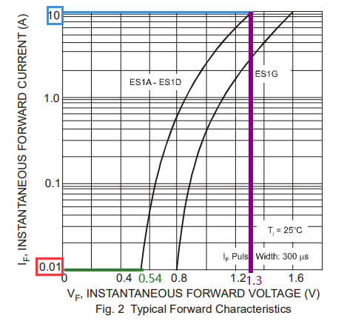

Fig.4.2 – Diode parameters for 25⁰C

$V_{fwd_max}\left(I_{fwd_imp}\right)=1.3$ (V)

Diode threshold voltage:

$v_{ON}=0.54$ (V)

### Diode active resistance:

$r_{VD}=\frac{V_{fwd_max}-v_{ON}}{I_{fwd_{imp} - I_{fwd}\left(v_{ON}\right)}}=$ 0.0761 (Ω)

## Diode rectifier without filter (Part 4.3 is optional for LAB 1 report. It is considered as Practice 1 Task)

### Average load voltage

$V_{{R_{L}}_{AVG}}=\left\{\begin{aligned}\frac{V_{S}}{π},\text{ for} \text{HWR} \text{schemes} \\ \frac{2∙V_{S}}{π}, \text{for }\text{FBR}\text{ or }\text{CTR}\text{ schemes}\end{aligned}\right.=$ 31.831 (V)

### RMS load voltage:

$V_{{R_{L}}_{RMS}}=\left\{\begin{aligned}\frac{V_{S}}{2} ,\text{ for} \text{HWR} \text{schemes} \\ \frac{V_{S}}{\sqrt{2}},\text{ for }\text{FBR}\text{ or }\text{CTR }\text{schemes}\end{aligned}\right.=$ 35.3553 (V)

### Max peak diode reverse voltage:

$V_{{VD}_{max}}=V_{S}=$ 50 (V)

### Average load current:

$I_{L_{AVG}}=\frac{V_{{R_{L}}_{AVG}}}{R_{L}}=\left\{\begin{aligned}\frac{V_{S}}{πR_{L}},\text{ for}\text{ HWR} \text{schemes} \\ \frac{2∙V_{S}}{πR_{L}},\text{ for }\text{FBR}\text{ or }\text{CTR}\text{ schemes}\end{aligned}\right.$ =0.1768 (A)

### RMS load current:

$I_{L_{RMS}}=\frac{V_{{R_{L}}_{RMS}}}{R_{L}}=\left\{\begin{aligned}\frac{V_{S}}{2R_{L}},\text{ for} \text{HWR} \text{schemes} \\ \frac{V_{S}}{\sqrt{2}R_{L}},\text{ for }\text{FBR}\text{ or }\text{CTR}\text{ schemes}\end{aligned}\right.$ =0.1964 (A)

### Average diode rectified output current:

$I_{VD}=\left\{\begin{aligned}I_{L_{AVG}}, \text{for} \text{HWR} \text{schemes} \\ \frac{I_{L_{AVG}}}{2},\text{ for }\text{FBR}\text{ or }\text{CTR}\text{ schemes}\end{aligned}\right.$ =0.0884 (A)

### Peak repetitive forward output current:

$I_{{VD}_{max}}\left\{\begin{aligned}\frac{V_{S}}{R_{L}}, \text{for} \text{HWR} \text{schemes} \\ \frac{V_{S}}{2R_{L}},\text{ for }\text{FBR}\text{ or }\text{CTR}\text{ schemes}\end{aligned}\right.=$ 0.1389 (A)

### Voltage ripple evaluated from desired $K_{p}$:

$ΔU_{{R_{L}}_{}}=2∙K_{p}∙U_{{R_{L}}_{AVG}}$ =30.7758 (V)

### Voltage ripple evaluated:

$K_{p}=\sqrt{{\left(\frac{V_{{R_{L}}_{RMS}}}{V_{{R_{L}}_{AVG}}}\right)}^{2}-1}=$ 0.4834 (V)

### Voltage ripple evaluated for the rectifier scheme:

$ΔV_{R_{L}}=2∙K_{p}∙V_{{R_{L}}_{AVG}}=$ 30.5 (V)

Conclusion: to provide required $K_{p} (ΔV_{R_{L}})$ additional C- filter is required

## Diode rectifier with filter (Part 4.3 is optional for LAB 1 report. It is considered as Practice 1 Task)

### Source output resistance (overcurrent protection):

$r_{on}=r_{V_{S}}= \frac{V_{S}}{I_{FSM}}=$ 1.6667 (Ω)

### Input rectifier resistance:

$r_{IN}=\left\{\begin{aligned}r_{vd}+r_{V_{S}}, \text{for} \text{HWR}\text{ or }\text{CTR} \text{schemes} \\ 2∙r_{vd}+r_{V_{S}},\text{ for FBR} \text{schemes}\end{aligned}\right. =$ 1.7427 (Ω)

### Starting (Non-repetitive) maximum peak surge diode current in rectifier scheme

$I_{{VD}_{ON}}=\frac{V_{S}}{r_{IN}}=$ 28.6904

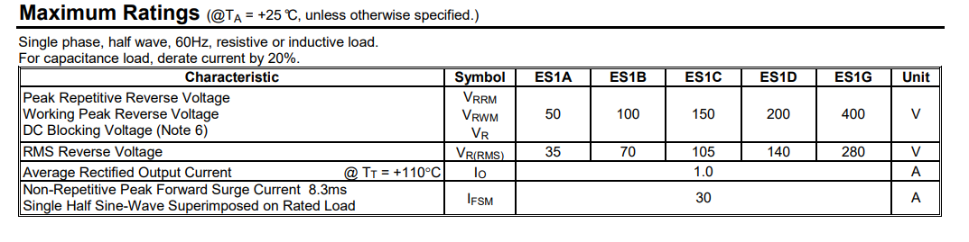

At this state, if $I_{VD_ON}>I_{FSM}$ it is necessary to increase $r_{Vs}= \frac{V_{S}}{I_{{VD}_{ON}}}$ and repeat evaluations 4.3.1-4.3.3.

### Diode opening state angle:

$θ= \left\{\begin{aligned}2∙\sqrt[3]{3∙π∙\frac{r_{IN}}{R_{L}}},\text{ for} \text{HWR} \text{schemes} \\ 2∙\sqrt[3]{\frac{3}{2}∙π∙\frac{r_{IN}}{R_{L}}},\text{ for }\text{FBR}\text{ or }\text{CTR}\text{ schemes}\end{aligned}\right.=$ 0.7147 (rad)

### Average load voltage

$V_{{R_{L}}_{AVG}}=V_{S}∙cos\left(\frac{θ}{2}\right)=$ 46.8417 (V)

### Average load current:

$I_{L_{AVG}}=\frac{V_{{R_{L}}_{AVG}}}{R_{L}}=\left\{\begin{aligned}\frac{1}{π∙r_{IN}}(V_{S}∙sin\left(\frac{θ}{2}\right)-V_{{R_{L}}_{AVG}}∙\frac{θ}{2})\text{, for} \text{HWR} \text{schemes} \\ \frac{2}{π∙r_{IN}}{(V}_{S}∙sin\left(\frac{θ}{2}\right)-V_{{R_{L}}_{AVG}}∙\frac{θ}{2})\text{, for }\text{FBR}\text{ or }\text{CTR}\text{ schemes}\end{aligned}\right.=$ 0.2742 (A)

### Average diode current:

$I_{VD}=\left\{\begin{aligned}\frac{V_{S}}{R_{L}}∙cos\left(\frac{θ}{2}\right)=\frac{V_{S}}{R_{L}}∙cos\left(\sqrt[3]{3∙π∙\frac{r_{IN}}{R_{L}}}\right)\text{, }\text{for} \text{HWR} \text{schemes} \\ \frac{V_{S}}{2∙R_{L}}∙cos\left(\frac{θ}{2}\right)=\frac{V_{S}}{{2∙R}_{L}}∙cos\left(\sqrt[3]{\frac{3}{2}∙π∙\frac{r_{IN}}{R_{L}}}\right), \text{for }\text{FBR}\text{ or }\text{CTR}\text{ schemes}\end{aligned}\right.$ = 0.1301 (A)

Compare with:



### Maximum repetitive rectifier scheme diode current:

$I_{{VD}_{max}}=\frac{V_{S}-V_{{R_{L}}_{AVG}}}{r_{IN}}=\left\{\begin{aligned}\frac{V_{S}\left(1-cos\left(\sqrt[3]{3∙π∙\frac{r_{vd}+r_{V_{S}}}{R_{L}}}\right)\right)}{r_{vd}+r_{V_{S}}}\text{, for} \text{HWR} \text{schemes} \\ \frac{V_{S}\left(1-cos\left(\sqrt[3]{\frac{3}{2}∙π∙\frac{r_{vd}+r_{V_{S}}}{R_{L}}}\right)\right)}{r_{vd}+r_{V_{S}}}\text{, for} \text{CTR} \text{schemes} \\ \frac{V_{S}(1-cos\left(\sqrt[3]{\frac{3}{2}∙π∙\frac{2∙r_{vd}+r_{V_{S}}}{R_{L}}}\right))}{2∙r_{vd}+r_{V_{S}}}, \text{for }\text{FBR}\text{ schemes}\end{aligned}\right.$ =1.8122 (A)

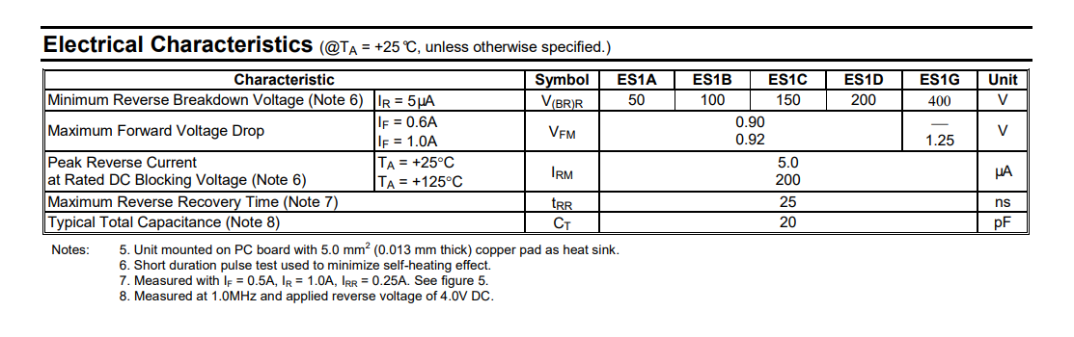

Compare with capacitor rated current.

### Peak repetitive reverse voltage:

$V_{{VD}_{max}}=\left\{\begin{aligned}V_{S}+V_{{R_{L}}_{AVG}}, \text{for} \text{HWR} \text{schemes} \text{or }\text{CTR}\text{ schemes} \\ \frac{V_{S}+V_{{R_{L}}_{AVG}}}{2},\text{ for }\text{FBR} \end{aligned}=\right.96.8417$

Compare with:

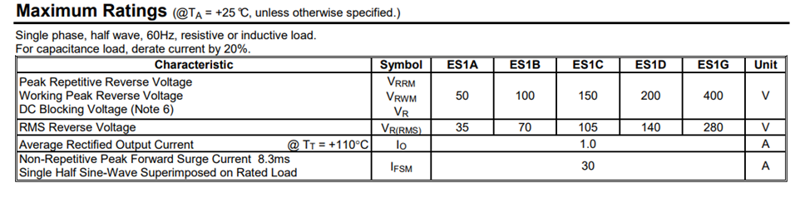

### Voltage ripple evaluated for the $K_{p}$ from given variant data:

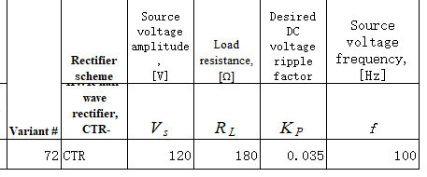

$ΔV_{R_{L}}=\left\{\begin{aligned}\frac{I_{L_{AVG}}}{2πf∙C}\left(2π-θ\right)={K_{p}V}_{{R_{L}}_{AVG}}2\sqrt{3}\text{, }\text{for} \text{HWR} \text{schemes} \\ \frac{I_{L_{AVG}}}{2πf∙C}\left(π-θ\right)={K_{p}V}_{{R_{L}}_{AVG}}2\sqrt{3}\text{, for }\text{FBR}\text{ or }\text{CTR}\text{ schemes}\end{aligned}\right.$ = 3.2789 (V)

## Capacitor evaluation

### Capacitance evaluation:

C $=\left\{\begin{aligned}\frac{I_{L_{AVG}}}{2πf∙ΔV_{R_{L}}}\left(2π-θ\right) , \text{for} \text{HWR} \text{schemes} \\ \frac{I_{L_{AVG}}}{2πf∙ΔV_{R_{L}}}\left(π-θ\right),\text{ for }\text{FBR}\text{ or }\text{CTR}\text{ schemes}\end{aligned}\right.$ = 0.0003 (F)

Pay attention to maximum tolerance rating: for the example in this case 20% $C_{real}^{ }=\frac{C}{0,8}=1,25C$ = 0.000375 (F)

(100%-20%) $C_{real}^{ }≥C=$ 0.0003 (F)

### After the nominal value is chosen:

$C_{real}^{ }$ =0.000375 (F)

0.8 $C_{real}^{ }$ =0.0003 (F)

1.2 $C_{real}^{ }$ = 0.00045 (F)

## Expected parameters of the developed rectifier

### Voltage ripple:

$ΔV_{{R_{L}}_{}}=\left\{\begin{aligned}\frac{I_{L_{AVG}}}{2πf∙0.8C_{real}^{ }}\left(2π-θ\right) , \text{for} \text{HWR} \text{schemes} \\ \frac{I_{L_{AVG}}}{2πf∙0.8C_{real}^{ }}\left(π-θ\right), for FBR or CTR schemes\end{aligned}\right.=$ 3.2789 (V)

$ΔV_{{R_{L}}_{}}=\left\{\begin{aligned}\frac{I_{L_{AVG}}}{2πf∙C_{real}^{ }}\left(2π-θ\right) , \text{for} \text{HWR} \text{schemes} \\ \frac{I_{L_{AVG}}}{2πf∙C_{real}^{ }}\left(π-θ\right), for FBR or CTR schemes\end{aligned}\right.=$ 2.6231 (V)

$ΔV_{{R_{L}}_{}}=\left\{\begin{aligned}\frac{I_{L_{AVG}}}{2πf∙1.2C_{real}^{ }}\left(2π-θ\right) , \text{for} \text{HWR} \text{schemes} \\ \frac{I_{L_{AVG}}}{2πf∙{1.2C}_{real}^{ }}\left(π-θ\right), for FBR or CTR schemes\end{aligned}\right.=$ 2.1859 (V)

### Voltage ripple factor:

$K_{p}≈\frac{\frac{ΔV_{R_{L}}}{2\sqrt{3}}}{V_{{R_{L}}_{AVG}}}$ = 0.021

## Comparing simulation and estimation results

### Average load voltage tolerance

$Δ_{V_{{R_{L}}_{AVG}}}$ = $\frac{\left|\left.V_{{R_{L}}_{AVG}exp}-V_{{R_{L}}_{AVG}}\right|\right.}{V_{{R_{L}}_{AVG}}}$ =1.97 (%)

### Ripple factor tolerance:

$Δ_{K_{P}}=\frac{\left|\left.K_{Pexp}-K_{P}\right|\right.}{K_{P}}∙100\%=$ 40 (%)

### Voltage ripple tolerance:

$Δ_{ΔV_{R_{L}}}$ =0.27 (%)

### Diode opening state angle tolerance:

$Δ_{θ}$ =5.97 (%)

### Maximum repetitive rectifier scheme diode current tolerance:

$Δ_{I_{{VD}_{max}}}$ =1.23 (%)

### Average rectifier scheme diode current tolerance:

$Δ_{I_{VD}}$ =0.077 (%)

### Starting (Non-repetitive) maximum peak surge diode current in rectifier scheme tolerance:

$Δ_{I_{{VD}_{ON}}}$ =13.9 (%)

Table 4.1 Tolerance report

|  |  |  |  |
| --- | --- | --- | --- |
| Parameter | Desired/evaluated value | Simulation result | Tolerance % |
| $V_{{R_{L}}_{AVG}}$ (V) | 46.8417 | 45.918 | 1.97 |
| $$K_{P}$$ | 0.035 | 0.021 | 40 |
| $ΔV_{R_{L}}$ (V) | 3.2789 | 3.27 | 0.27 |
| $θ$ (rad) | 0.7147 | 0.672 | 5.97 |
| $I_{{VD}_{max}}$ (A) | 1.8122 | 1.79 | 1.23 |
| $I_{VD}$ (A) | 0.1301 | 0.13 | 0.077 |

# Conclusions

Conclusions should contain:

1) Diode check results:

* Is breakdown voltage check passed? /Is voltage source changed because of overvoltage?

Yes/Yes

* Is starting current check passed? /Is additional resistance r_vs added to prevent overcurrent in diode/capacitor?

Yes/Yes

2) Capacitor information: nominal value, tolerance, allowed current

.MODEL D_VAR_0 D ( IS=123n RS=42.0m BV=100 IBV=5.00u+ CJO=18.5p M=0.333 N=2.12 TT=28.8n )

3) Provided ripple factor value

0.035

# Appendix А.

### ES1B

|  |
| --- |
|  |
| a) |
|  |
| b) |

Fig.1. Diode parameters for 25⁰C

# Appendix В. VariantNo72.lib listing